Billing & Subscription page:

In the above screenshot, can we remove the comma before and?
Also on this page, can we change the $ signs to £ signs?

Feel free to disagree with this one:
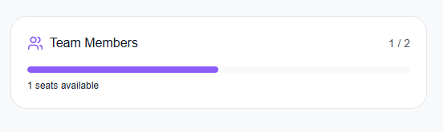
In the above screenshot, we’re letting them know they have 1 user available, should we have a button to invite / add a user here, or not?

Team Members page
 Should these buttons be doing anything? They don’t work for me
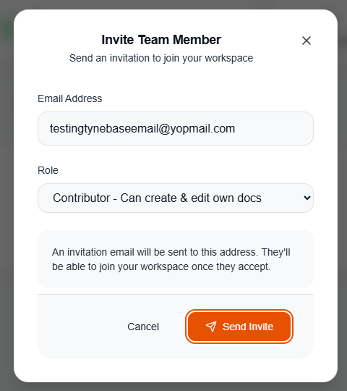
In the above screenshot, the send invite button isn’t working
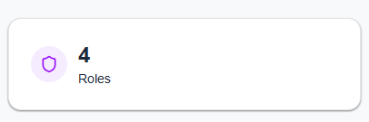 I wonder if it’s worth making this clickable to explain what the roles are?

Settings screen
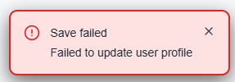 When trying to save changes in the settings screen, I get this error

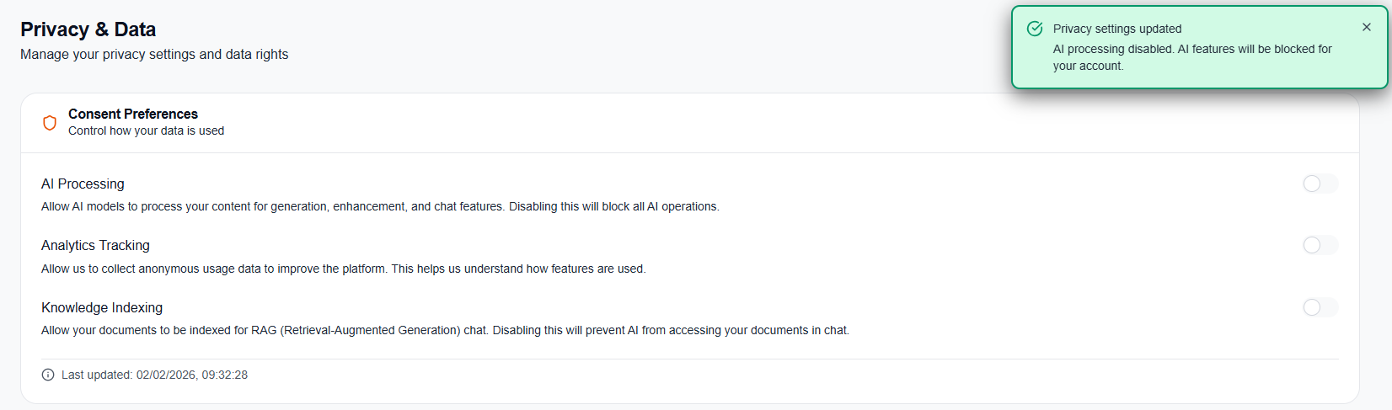
In the above screenshot, when I select multiple options, I still only get one message. When someone does this, can we put in both wordings? E.g. Your AI processing AND consent preferences have been changed?

In the above screenshot, can we just remove the comma before … and profile?
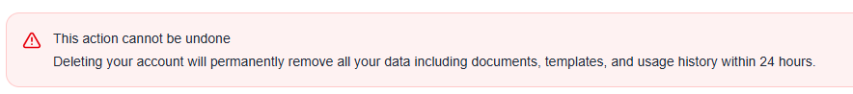
In the above screenshot, can we bold ‘This action cannot be undone’ and remove the comma before … and usage history?
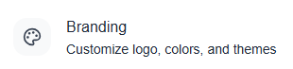
Can we change Customize to Customise, change colors to colours and remove the comma after colours?

Brandings page
 Can we change Customize to Customise?
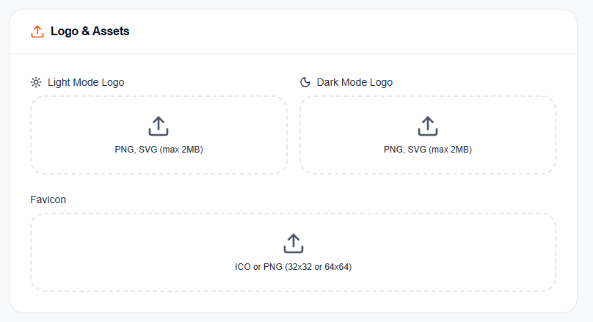
In the above screenshot, none of these seem to be working at the moment. Also, are we planning on offering drag and drop? Just wondering!

Also, with ‘Reset All’ should this reset any changes to the company name as well? I feel like it is a capture reset all on this page.

Audit logs screen
 Should this be a clickable link?
 Can we remove the comma before … or target?

Templates screen

Can we just add one comma in here? ‘…article you need, or create your own’
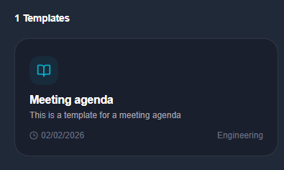
In the above screenshot, is it possible for when there is only 1 template, for it to say ‘1 Template’ instead of Templates?

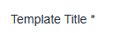 Can we take out the space between title and *
 Can we say ‘Create a Template’ and remove the comma before … or let
 Can we remove the space between Content and *
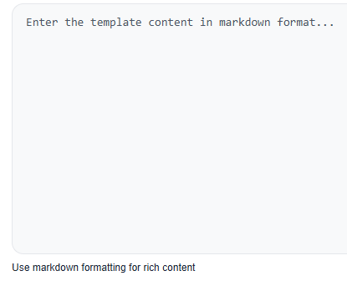
In the above screenshot, I wonder if ‘markdown format’ and ‘rich content’ should be reworded or have a hover over to explain? Just thinking not everyone might know what it means. What do you think?
In the above screenshot, can we remove the comma after e.g. and the comma before … and implementation…

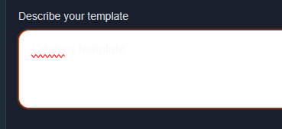 In dark mode, you can’t see the text here.
When trying to create a template with both DeepSeek and Claude, I get the above error.
 Can we remove the space between Category and *
 Can we change this to say:
‘There are no categories yet, click + New Category to create one’
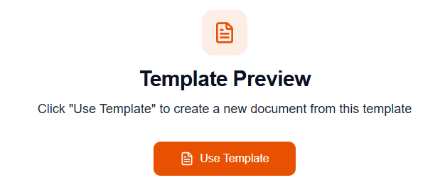
In the above screenshot, can we remove the “ “ around Use template?
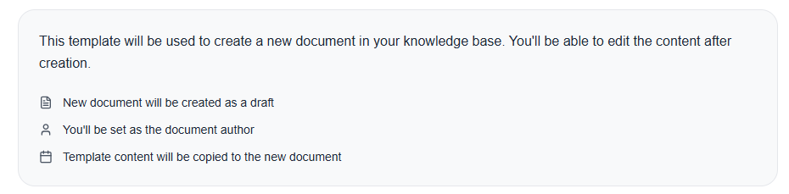
In the above screenshot, can we just change it slightly:
‘A new document will be created as a draft
The template content will be copied to the new document’
 Is there any way to either hide this or change it to something that means something?

Community screen
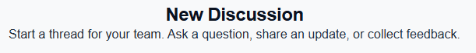
Can we remove the comma before … or collect?

Can we remove the comma before …and include?
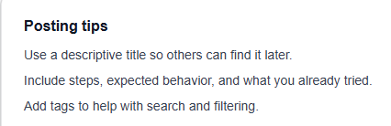
Can we remove the comma before … and what you already tried.?
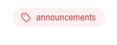 Can we add a capital letter to these categories?
 The post new discussion button isn’t working

New feature idea? – Is it possible to have a polling system in the community posts?

Content audit screen

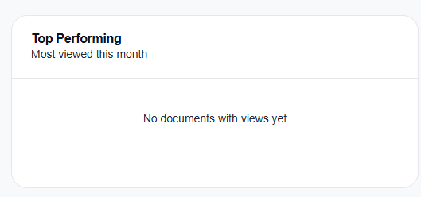
I don’t have any documents showing here, even though I have documents in my instance.
Dashboard screen
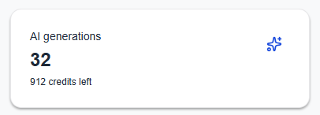 How quickly does this update? This says 912 but top right says 917 now..
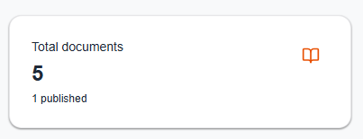 Can clicking this take the user to the list of their documents?
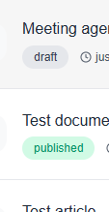 Can we add a capital letter to these tags?

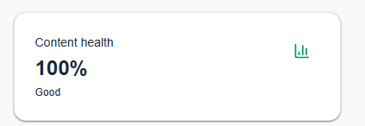 This might be silly, but should 100% not be excellent or something? Hah
All documents screen
When I edit a published document and go in to make changes, can we have a ‘save changes’ button or something? I can only see:
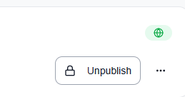
We don’t want users having to unpublished and re-publish every time they want to make a change.
So maybe we have ‘save as draft’ and when an article is in draft state, unpublish changes to publish automatically?
And if they want to save and publish changes instantly, we can have a ‘Save and Publish’ button?

Can we change normalized to normalised?

When deleting multiple documents:
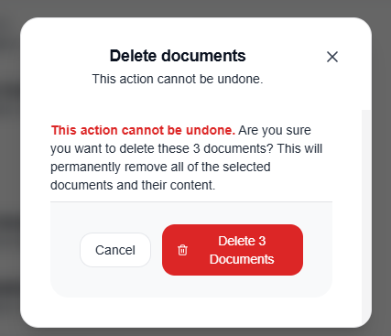
Can we remove the duplicate ‘This action cannot be undone’ and have the bold one directly under ‘Delete documents’?
Can we also remove the number from the button?

Is it possible to have a confirmation screen once the documents have been deleted?

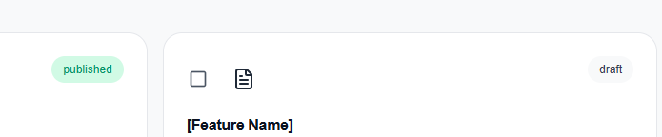
Can these above tags have a capital starting letter?

 When I click this I get a 404.
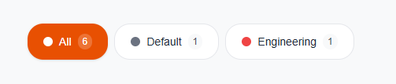 Can we add a header above these to say Categories?
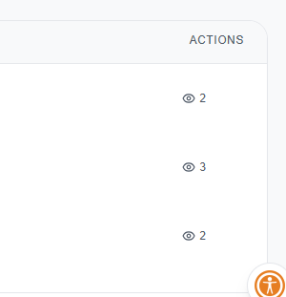
In the above screenshot, the views seems to have moved under actions. Can it have it’s own column? Also, the actions aren’t currently being displayed.
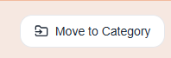 Can we change this to say ‘Assign a Category’

When assigning a documents category:
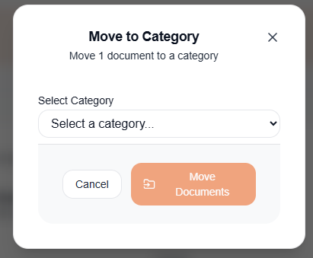

Can we change this screen to say:
‘Assign a Category
Assign [0] documents a category
<Dropdown>
<Cancel> <Assign category>

In the dropdown:
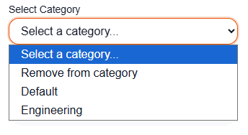
Can we remove ‘Select a category’ from this list? And in the list, have:
Uncategorised
[Example category]
[Example category]

Etc.? And is it possible to have a confirmation screen once assigned?
When assigning a tag:
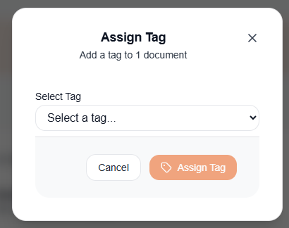
Can we change this to say:
‘Assign a Tag
Add a tag to [0] documents
<Select a tag..>
<Cancel> <Assign Tag>

When selecting a tag:
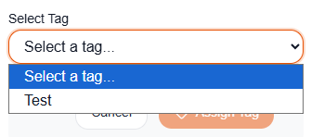
Can we remove the ‘Select a tag..’ from the drop down menu and only show available tags? And can we get a confirmation screen here?

When adding documents to a collection:
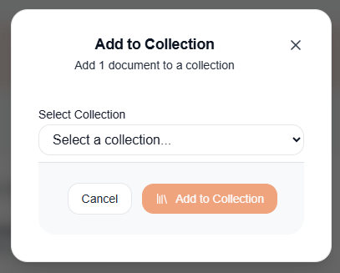
Can we change this to say:
‘Add to a collection
Add [0] documents to a collection]
<Choose a collection>
<Cancel> <Add to Collection>

And in the dropdown:
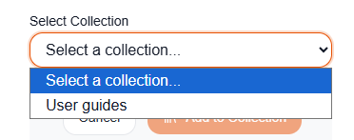
Can we remove ‘Selection a collection…’ from the downdown and only show available collections? Can we have a confirmation screen here too?

 I am not sure we need this, based on the status column showing this. What do you think?

When I click All documents, then another option in the KB section:
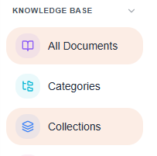
Both are highlighted
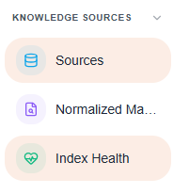
It’s the same with sources in the knowledge sources section
Tags aren’t shown in this table, but we can filter by them:
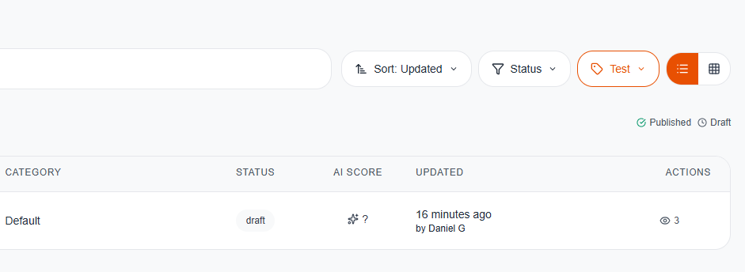

Q. Is it possible to enable drag and drop straight into an article when drafting or editing an article?
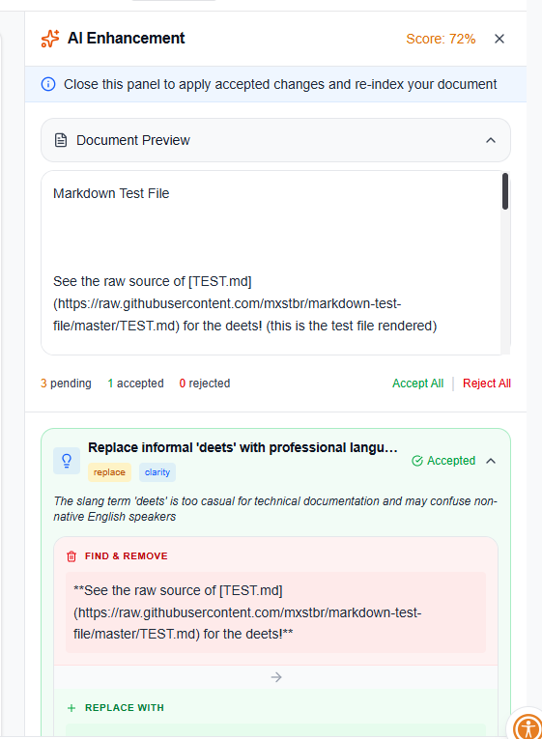
In the above screenshot, you can see the AI changes offered to a document, but when I scroll, the entire page scrolls. Would it be possible to have this scroll independently, so I can still see my article? Or not?

When using the AI Enhancement whilst editing a document, it doesn’t seem to actually make the changes suggested, and is also doing other bits not suggested – adding random letters, taking away random spaces etc.
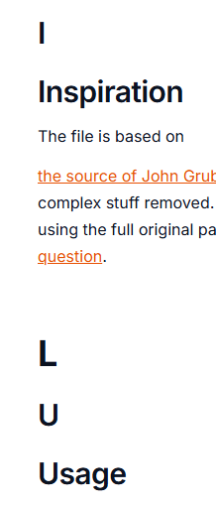
I didn’t add these letters. Etc. Happy to jump on a call and show you where it’s happening.
Categories screen
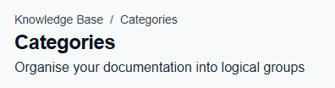 Can we remove the Knowledge Base / Categories bit? It doesn’t seem to be anywhere else.

Curious your thoughts on this button? Do you think we need a button here to take users to those articles in that category, if so, should it be more obvious? Maybe we don’t have this button and if they just click the category?

Is it possible to add one filter for the categories, so users can filter by most recently created?
When deleting a category:
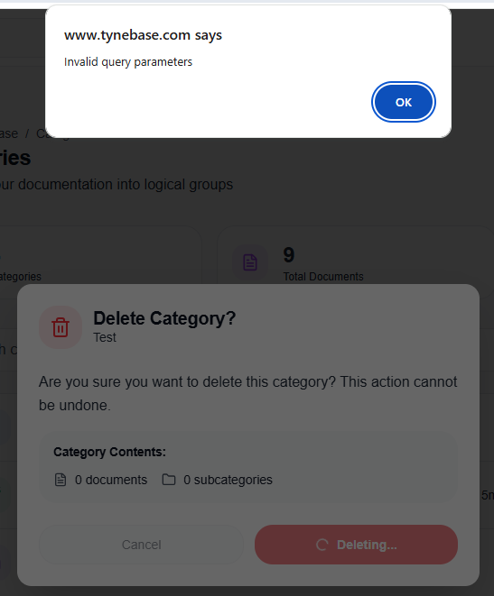
I get the following error.
Also, should we make the default category non-deleteable? And if a client deletes a category that is attached to docs, they automatically revert to the default category? Or not?
Collections screen
When deleting a collection:
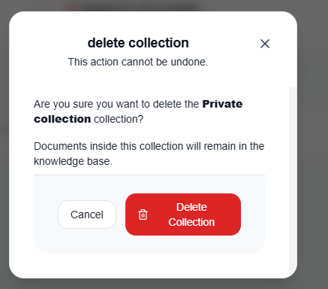
Can we add capital letters to Delete and Collection?
And can we get a confirmation screen?

 Filters doesn’t seem to work here
Are private collections private to the user or the company?
Tags screen
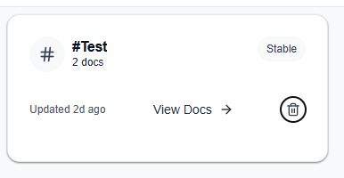 The delete button isn’t working here.
Imports screen
 Filters on this screen doesn’t seem to work.
Activity screen
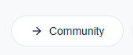 What’s the thought process behind a community button on this screen?
 The new document button directs to a 404
My drafts screen
 Can we remove the breadcrumb?
 What does the submit for review button do?

Sources screen
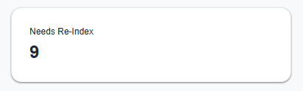 can this be changed to say ‘Needs Re-indexed’?
 Can we change this to say ‘Documents needing Re-indexing’?
 Filters seems to not be working on this page.


Can we change normalizes to normalises?
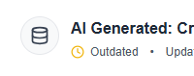 Once I index, it instantly says outdated. Is this right?
Normalised Markdown
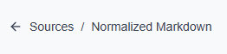 Can we remove this breadcrumb?
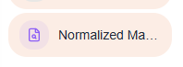 Can we change Normalized to Normalised here?
 Can we change Normalized to Normalised here too?
 Filter doesn’t seem to be working here.
 Can we add a capital letter to these tags? Published & Draft etc.
 Same here as above.
Index Health screen
 Can we remove this breadcrumb?
In the above screenshot, can we remove the comma before …and retrieval?
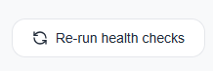 I am not sure this is working
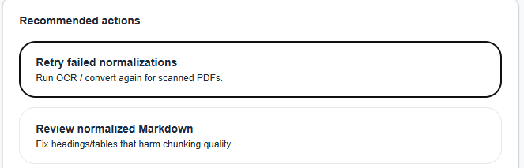
Are these buttons meant to do something? They don’t seem to work.

AI Chat screen
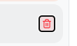 When clicking this we should give a warning screen
 If there is one conversation and you click the bin icon, it creates a new conversation for some reason.

Ingest screen
Also, these buttons in the document settings:

Don’t seem to be working.

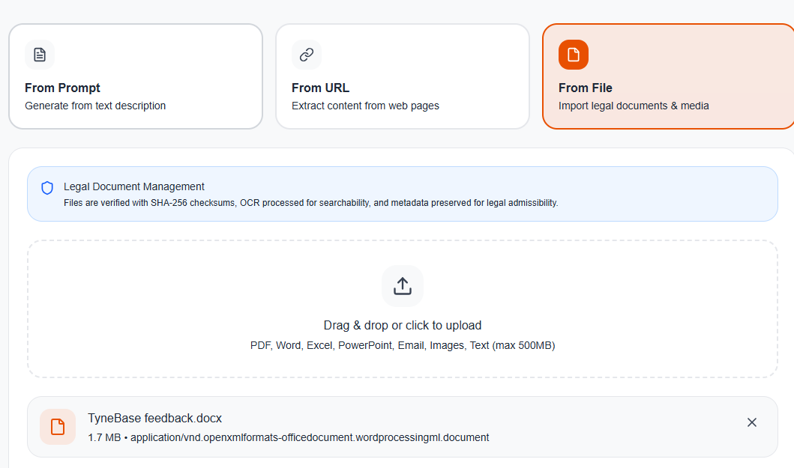
In the above image, when trying to upload a file, I get an error:
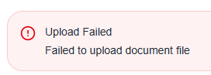

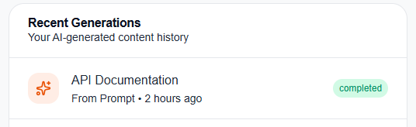
In the above image, it doesn’t seem to be showing all the recently generated content. Also can we have the tags have a capital letter at the start?
Also, clicking the article doesn’t take you anywhere.

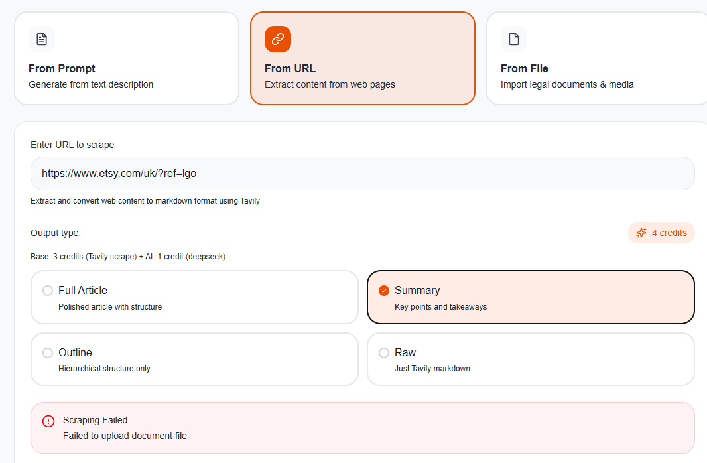
When trying to scrape from a URL I get the attached above error.
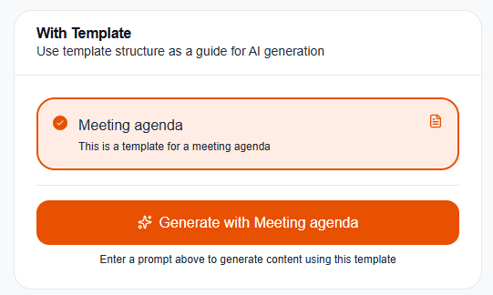
In the above screenshot, the generate button doesn’t seem to work on the right hand side.
From video screen
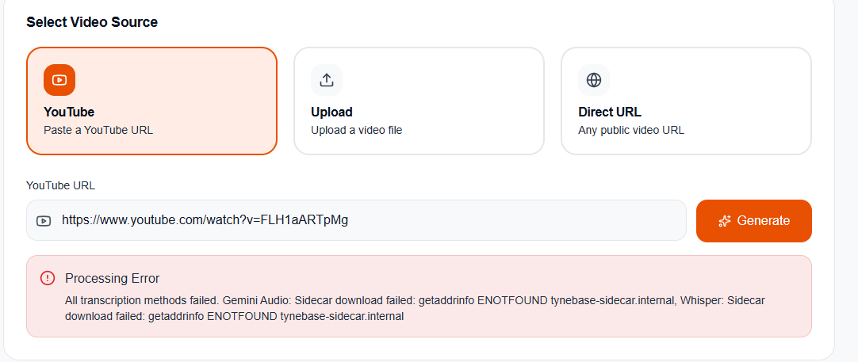
In the above screenshot, I am getting the attached error when trying to generate from a youtube link.
Same with the Direct URL option.

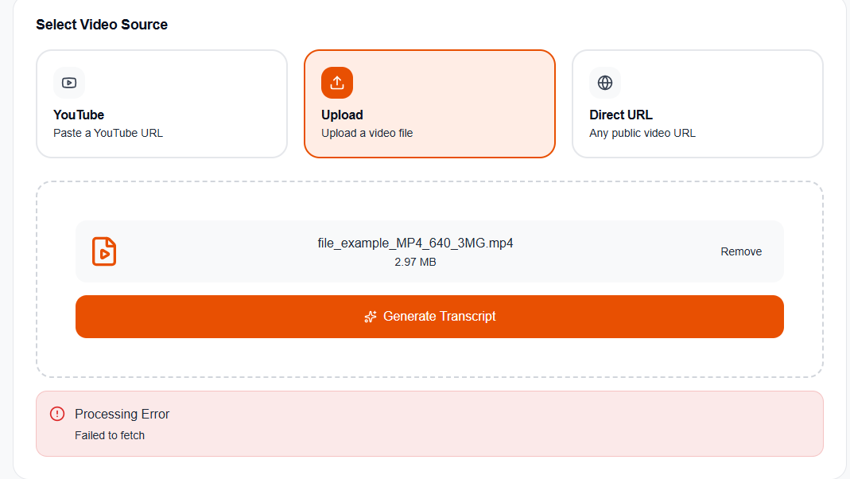
When trying to generate from an uploaded file, I get the above error.
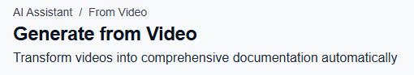
In the above screenshot, can we remove the breadcrumb and make a small change?:
‘Automatically transform videos into comprehensive documentation’
From audio screen
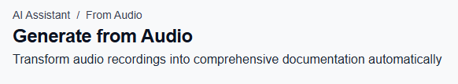
Can we remove the breadcrumb in the above screen and make a minor change?
‘Automatically transform audio recordings into comprehensive documentation’

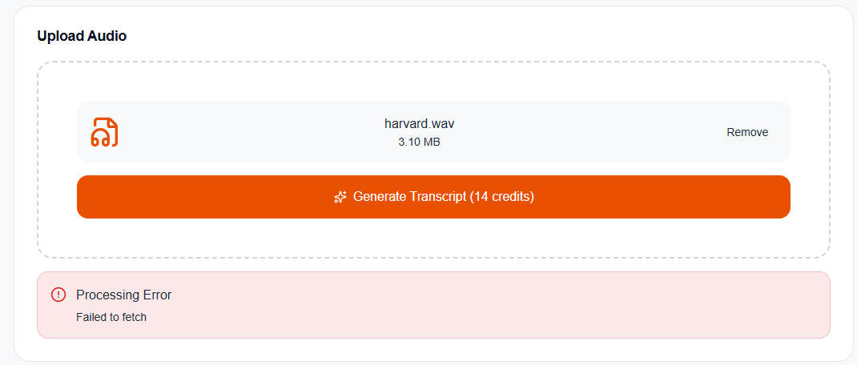
In the above screenshot, when trying to generate from an audio file, I get an error.

Enhance screen
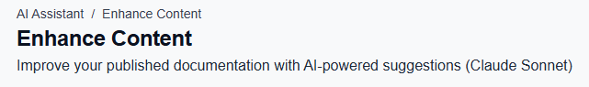
Can we remove the breadcrumb above?

 The apply all button isn’t working.
Once we have applied changes, can we have a button to take you to the article or something?
Once you enhance in this screen and click to enhance again, nothing happens. It doesn’t give more suggestions.

Do we have the option to add our own prompts to improve the pages? Instead of just running AI looking for enhancements, we could have a text input and say, I want to update this document for 20206. Etc.?

Notifications

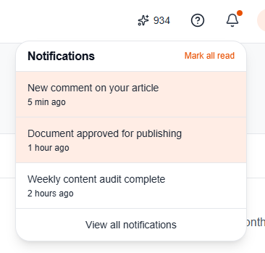
The notifications don’t do anything when clicked.
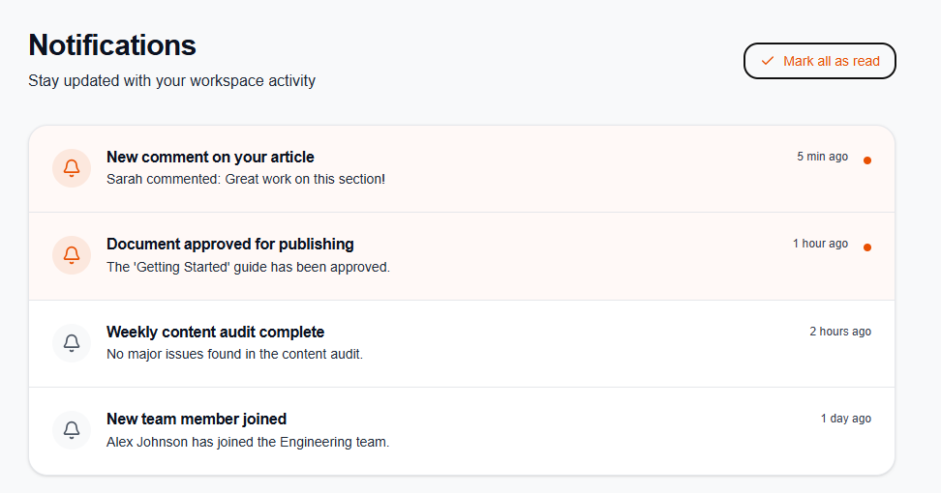
The Mark all as read doesn’t work & clicking notifications doesn’t take you anywhere either.

Settings screen

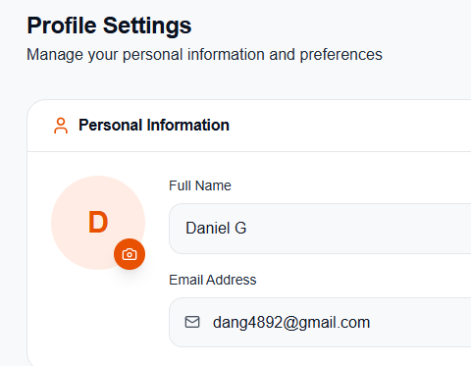
When I click save changes in the profile settings screen, the changes don’t actually save.

Help centre screen
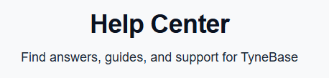
Can we remove the comma before …and support?

Users page
When inviting a user:
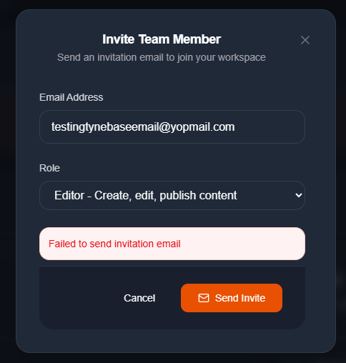
The button works, but I get an error.
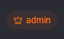 Can we make this ‘Admin’?
 Can we change this to ‘Invite users’?

Webhooks page
 Button isn’t working
Permissions page
 Create role isn’t working
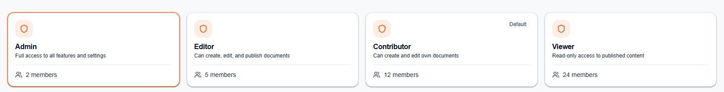
In the above screenshot, accurate numbers aren’t being shown.
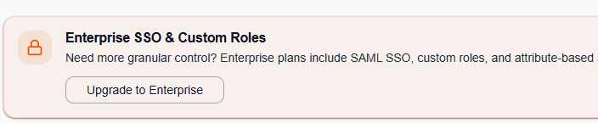
In the above screenshot, can we remove the comma before …and attribute?

